Lab 2: Setting Up the Database Context for a Retail Store

Category Model:
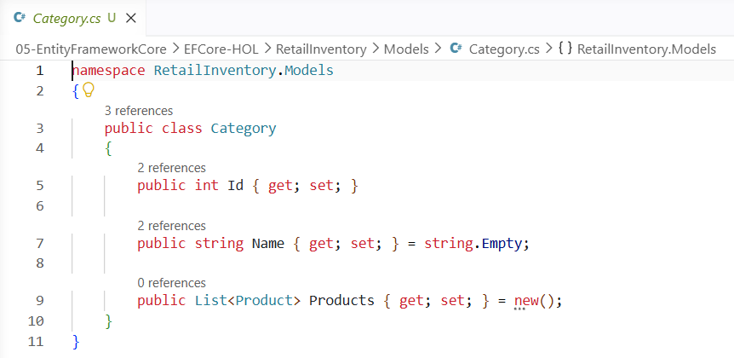
Product Model:
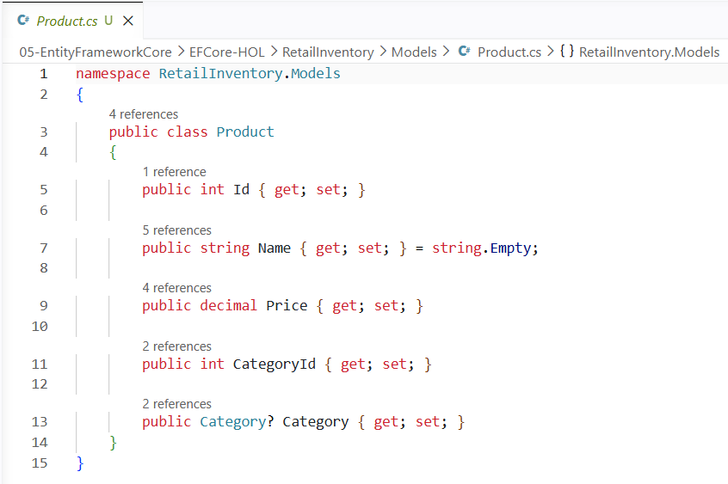

AppDbContext.cs:
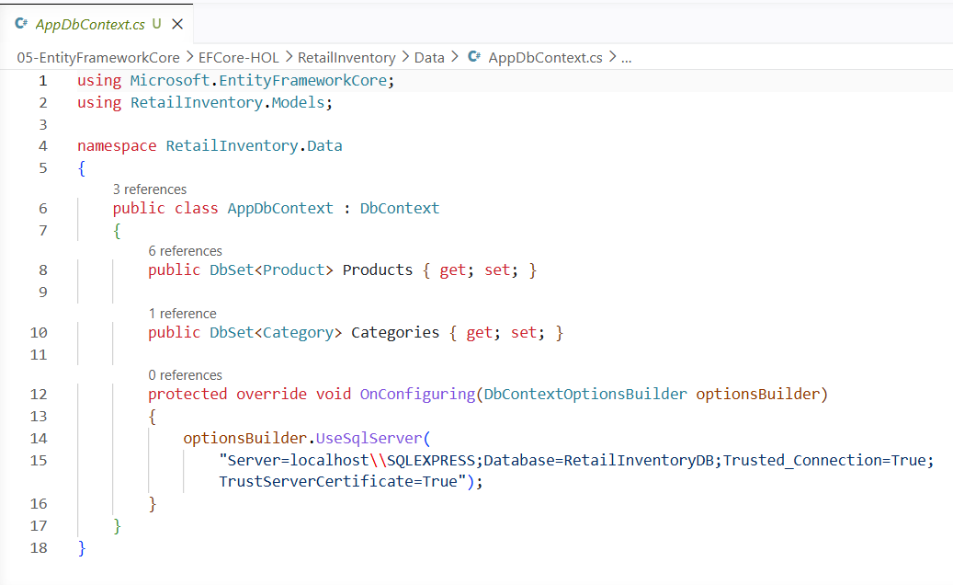

Build Project:
dotnet build
Output:
